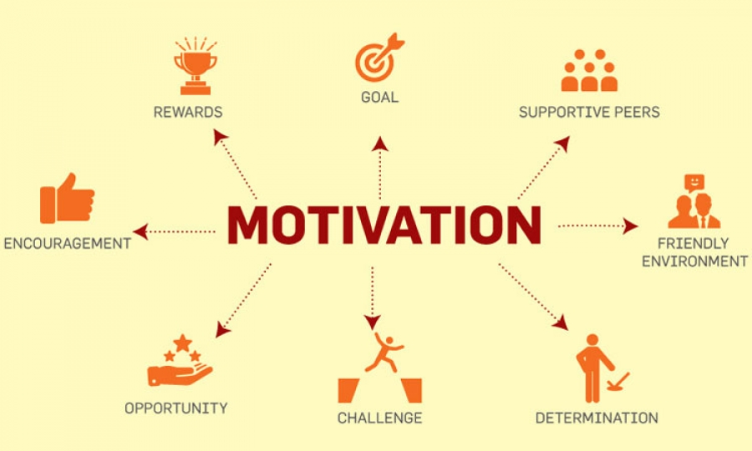**Summary of Chapter 8**

**Motivation** is the word derived from the word 'motive' which **means** needs, desires, wants or drives within the individuals. It is the process of stimulating people to actions to accomplish the goals. In the work goal context the psychological factors stimulating the people's behaviour can be - desire for money. success.

**What Is Maslow’s Hierarchy of Needs?**

* Maslow's hierarchy of needs is a motivational theory in psychology comprising a five-tier model of human needs, often depicted as hierarchical levels within a pyramid.
* Needs lower down in the hierarchy must be satisfied before individuals can attend to needs higher up.
* From the bottom of the hierarchy upwards, the needs are: physiological, safety, love and belonging, esteem, and self-actualization.

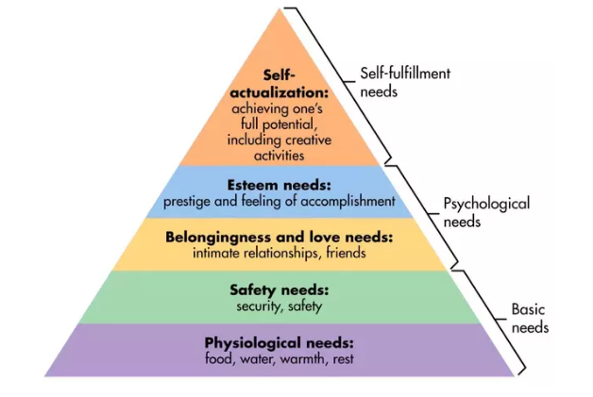

* 1. **Physiological needs** - these are biological requirements for human survival, e.g. air, food, drink, shelter, clothing, warmth, sex, sleep.

If these needs are not satisfied the human body cannot function optimally. Maslow considered physiological needs the most important as all the other needs become secondary until these needs are met.

* 2. **Safety needs** - protection from elements, security, order, law, stability, freedom from fear.
* 3. **Love and belongingness needs** - after physiological and safety needs have been fulfilled, the third level of human needs is social and involves feelings of belongingness. The need for interpersonal relationships motivates behaviour
* Examples include friendship, intimacy, trust, and acceptance, receiving and giving affection and love. Affiliating, being part of a group (family, friends, work).
* 4. **Esteem needs** - which Maslow classified into two categories: (i) esteem for oneself (dignity, achievement, mastery, independence) and (ii) the desire for reputation or respect from others (e.g., status, prestige).
* Maslow indicated that the need for respect or reputation is most important for children and adolescents and precedes real self-esteem or dignity.
* 5. **Self-actualization needs** - realizing personal potential, self-fulfillment, seeking personal growth and peak experiences. A desire “to become everything one is capable of becoming”.

**McGregor’s Theory X and Theory Y**

|  |  |
| --- | --- |
| Theory X | Theory Y |
| * Assumes that workers have little ambition, dislike work, avoid responsibility, and require close supervision. * This part looks at the issues and negative aspect within the organization. | * Assumes that workers can exercise self-direction, desire responsibility, and like to work. * Gives more freedom and provides a positive environment and also focus to the good side of things |

**Herzberg’s Motivation-Hygiene Theory**

Broken down into two parts

|  |  |
| --- | --- |
| Hygiene Factor ( -) | Motivational Factor (+) |
| **Extrinsic** (environmental) factors that create job dissatisfaction.  **Extrinsic** motivation is when someone does something for external rewards or to avoid negative consequences. | **Intrinsic** (psychological) factors that create job satisfaction.  **Intrinsic** motivation occurs when someone does something because they love to do it or find it interesting |

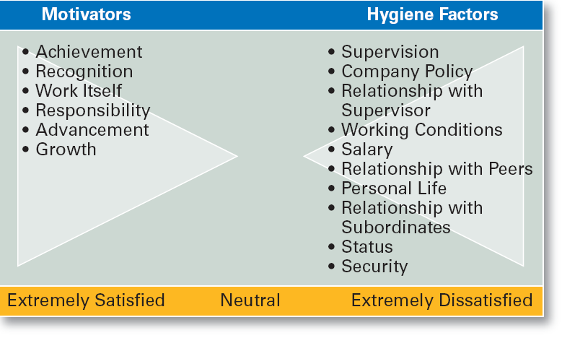

Extremely Satisfied – The staff is happy with all conditions and willing to do more

Neutral – the staff is either happy or dissatisfied but rather they are in the 50 50 situation

Extremely dissatisfied – the staff is not happy and demotivated and doesn’t want to perform or intends to leave.

**Three-Needs Theory (McClelland)**

|  |  |  |
| --- | --- | --- |
| **Need for Achievement (nAch)** | **Need for Power (nPow)** | **Need of Affiliation (nAff)** |
| **Achievement**   * A thing done successfully with effort, skill, or courage. * The process or fact of achieving something | **Power**  The capacity or ability to direct or influence the behaviour of others or the course of events. | **Affiliation**  The focus on the network and influence of an individual in the society.  Looks at the interpersonal skills and also being able to communicate with others. |

**Reinforcement Theory**

* The process of encouraging or establishing a belief or pattern of behaviour.
* Assumes that a desired behavior is a function of its consequences, is externally caused, and if reinforced, is likely to be repeated.
* It’s better to use positive approaches to perform reinforcement as this minimizes resistance and negativity.

**Equity Theory**

* **Equity =** being equal and neutral in all situations and not being bias in making decisions as one will look at both sides and also evaluate this fairly.
* Proposes that employees perceive what they get from a job situation (outcomes) in relation to what they put in (inputs) and then compare their inputs-outcomes ratio with the inputs-outcomes ratios of relevant others.

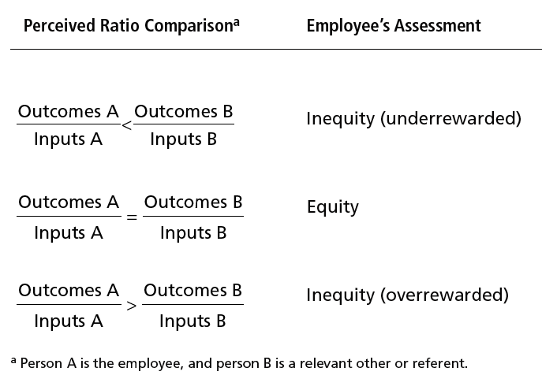

**Expectancy Theory (Vroom)**

**Expectancy =** the state of thinking or hoping that something, especially something good, will happen.

States that an individual tends to act in a certain way based on the expectation that the act will be followed by a given outcome and on the attractiveness of that outcome to the individual.

**Focus on the following**

* + - **Effort:** employee abilities and training/development
    - **Performance:** valid appraisal systems
    - **Rewards (goals):** understanding employee needs

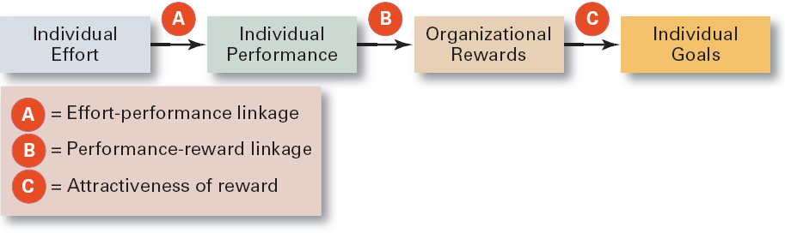

**Guidelines for Motivating Employees**

* Use goals
* Ensure that goals are perceived as attainable
* Individualise rewards
* Link rewards to performance
* Check the system for equity
* Use recognition
* Show care and concern for employees
* Don’t ignore money